**Exercise 3: Brainstorming and Initial Solution**

Last Updated 9.4.2018

Name: Akaninyene Eyoh, Daniel Yan, Ulysses Yu

Date: 12/1/2018

Course: CS 278

1. Write your design problem as a “How Might We” question:

*(How might we <encourage/help/support> <person> to <goal>?)*

How might we help Vanderbilt students find their way around Stevenson building?

1. 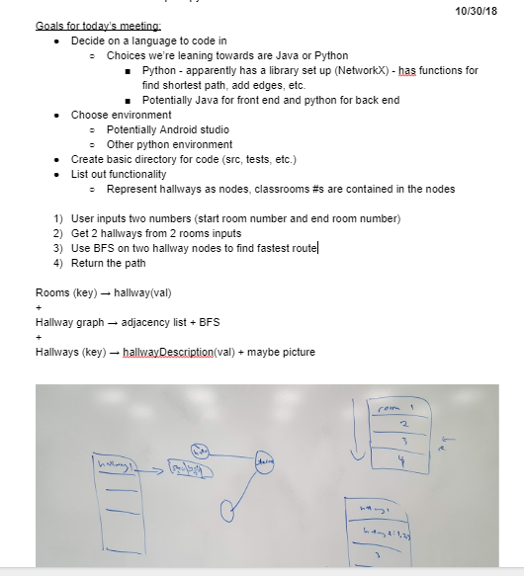In the box below, insert a photograph or (loosely) categorized list of **at least 10** of your brainstorming ideas from a team session.
2. In at least four sentences, discuss how your team evaluated the brainstormed ideas and converged on an initial solution.

We first evaluated our past experiences with the language options. Since two of us had used Python in the past and felt that it was fairly easy to create graphs structures (even without using an external library), we decided that a Python backend would be fairly reasonable to implement. One of our members had experience with using Flask to create a server that could call a Python backend, so we decided that we would go with a Python backend that would connect to a Java android app.

For the graph structure, we initially thought about modeling all the rooms and hallways as nodes, but we later decided to only model the hallways and staircases as nodes to reduce the number of nodes. Since each room is only connected to one hallway, we would create a map from room numbers to hallways so that when the user typed the start and end rooms, we would map those two rooms two hallways and find the shortest path between those hallways, which would yield all the hallways the user would need to traverse.

We decided to use breadth first search for our algorithm because that guaranteed the shortest path and the branching factor for hallways in Stevenson is fairly low.